Ischemic Heart Disorder

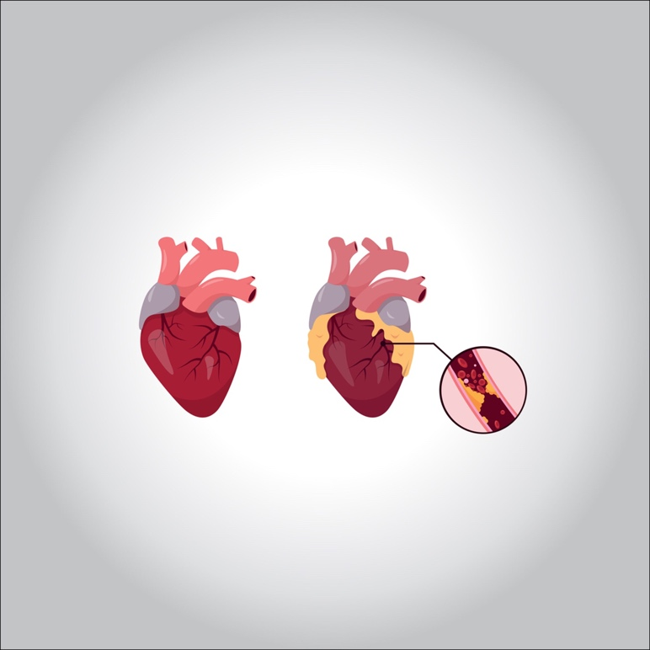

**What is the condition of ischemic heart failure?**

**In short, it is a decrease in blood flow. Diseases affecting the heart muscle are called. The most common cause is blockage or narrowing of the coronary arteries that supply the heart due to atherosclerosis, also known as atherosclerosis.**

**Is ischemic heart disease dangerous?**

**The lack of ischemia and oxygenation led to a heart attack that eliminated the heart attack. This leads to heart failure**

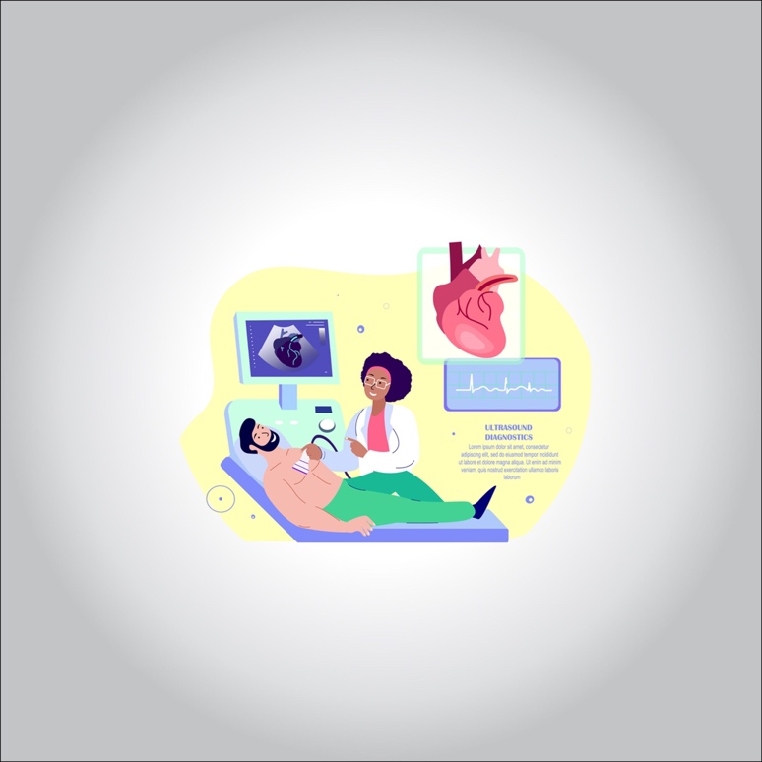

**Causes of ischemic heart disease:**

**Atherosclerosis is the main reason for stopping the rate of low blood pressure. Home entry and entry graph**

**Symptoms of ischemic heart failure:**

**Coronary artery symptoms appear. The emergence of some substances caused by malnutrition of the teeth and can also spread to other parts, causing pain**

**Other symptoms**

**Throwing a clot: For example, a clot from a clot formed in the heart may be delivered to the brain, leading to a blockage in the vessels of the brain.**

**Torsion: It is the twisting of blood vessels that wrap around some organs such as the ovaries, testicles, and intestines, and the blood flow in these vessels is disrupted due to the torsion.**

**Blood pressure: For example, the large size of a tumor leads to pressure on the blood vessels in its vicinity, which leads to a decrease in the amount of blood that crosses through the vessel. Thus, ischemia occurs in the organ fed by this vein**

**Brain: Life-threatening conditions such as stroke and hemiplegia can arise**

**Ischemia leads to ischemia**

**Intestines: severe abdominal pain due to ischemia of the blood vessels that supply the intestines**

**Stem cell treatment method**

**It will come into contact with the vessel wall. Heart cells turn into cells that help treat heart disease.**

**Increasing the strength of the immune system helps shorten the recovery period after the operation. It helps the heart recover from inflammation.**